Page 1 — Launch an EC2 Instance
Topic: EC2 instance creation and basic configuration
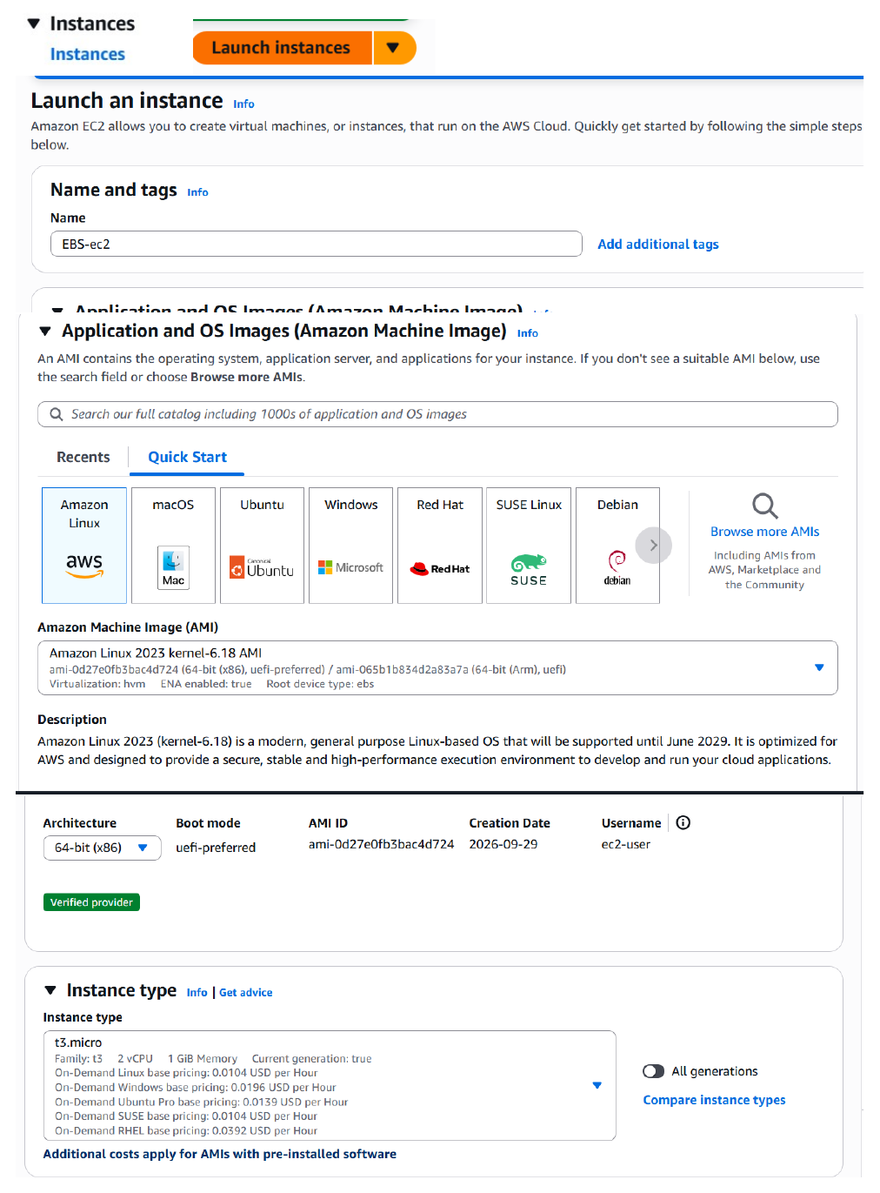
Actual action: The EC2 Launch an instance screen is opened and the Amazon Linux AMI and t3.micro instance type are selected/configured.

Page 2 — Configure Login and Network Settings
Topic: Key pair, VPC, subnet, public IP, and security group
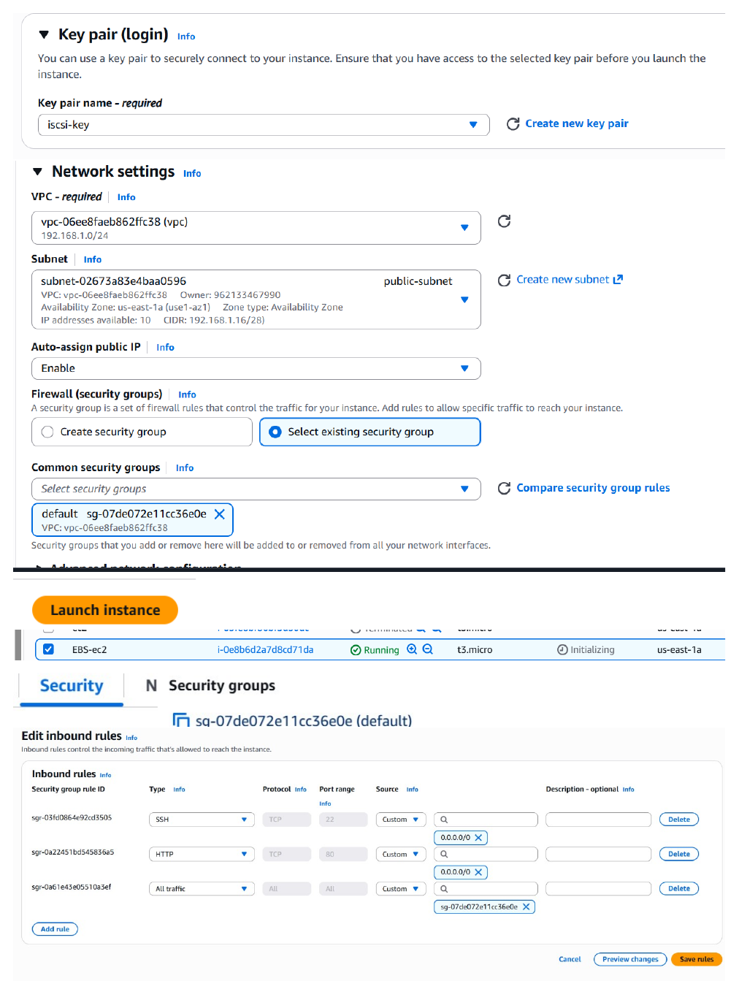
Actual action: The selected key pair, public subnet, public IP setting, and security group/inbound rules are configured before launching the instance.

Page 3 — Connect to the EC2 Instance
Topic: SSH connection and initial instance access
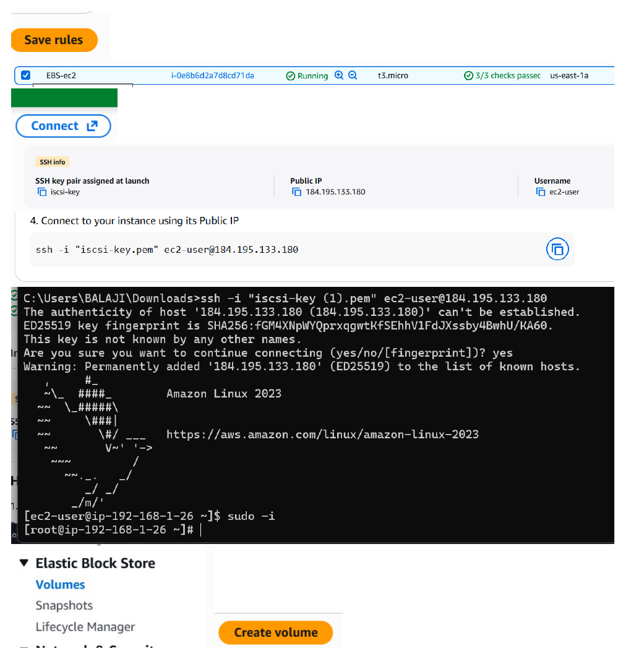
Actual action: The SSH command is used to connect to the public IP, the host key is accepted, and the Amazon Linux shell is opened.

Page 4 — Create an EBS Volume
Topic: Amazon EBS volume creation
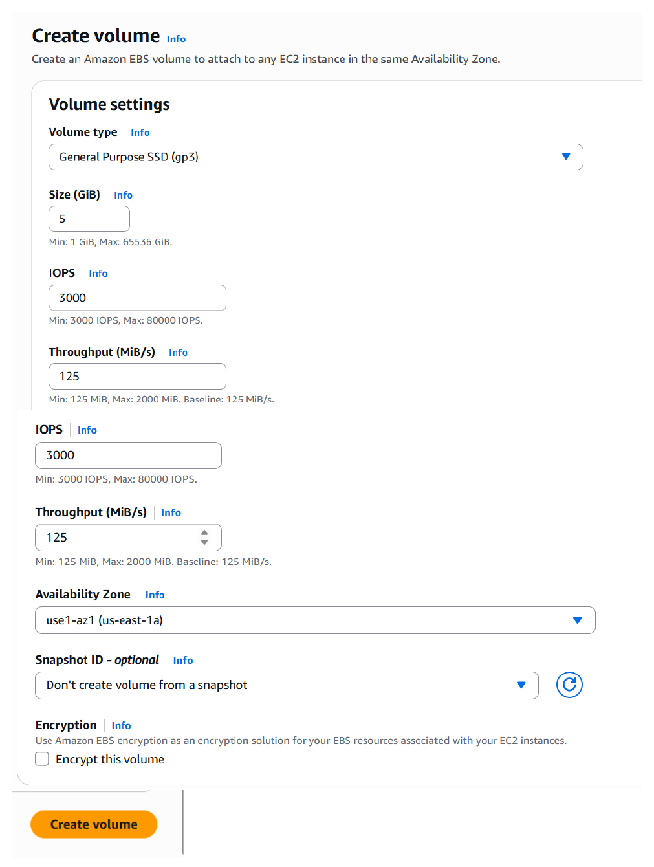
Actual action: A 5 GiB General Purpose SSD (gp3) EBS volume is configured in the same Availability Zone as the EC2 instance.

Page 5 — Attach the EBS Volume
Topic: Attaching EBS storage to the EC2 instance
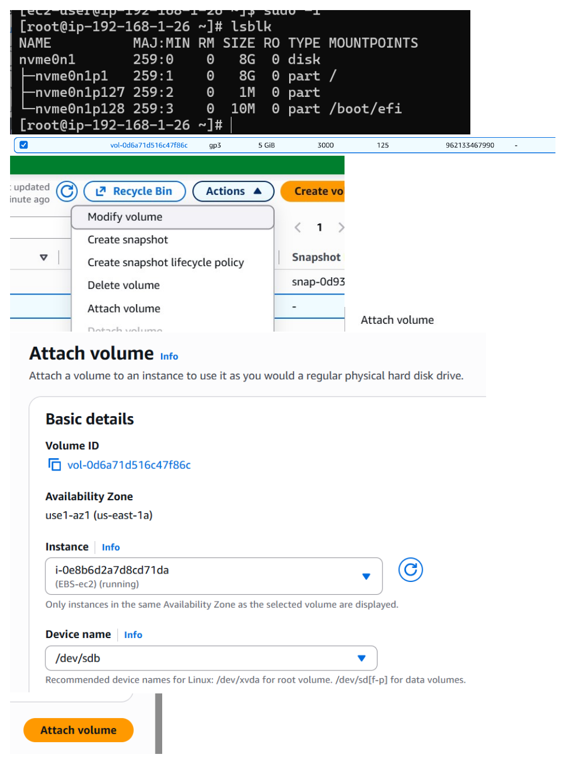
Actual action: The 5 GiB volume is selected and attached to the running EC2 instance using the /dev/sdb device name.

Page 6 — Verify the Attached Disk
Topic: Linux block-device verification
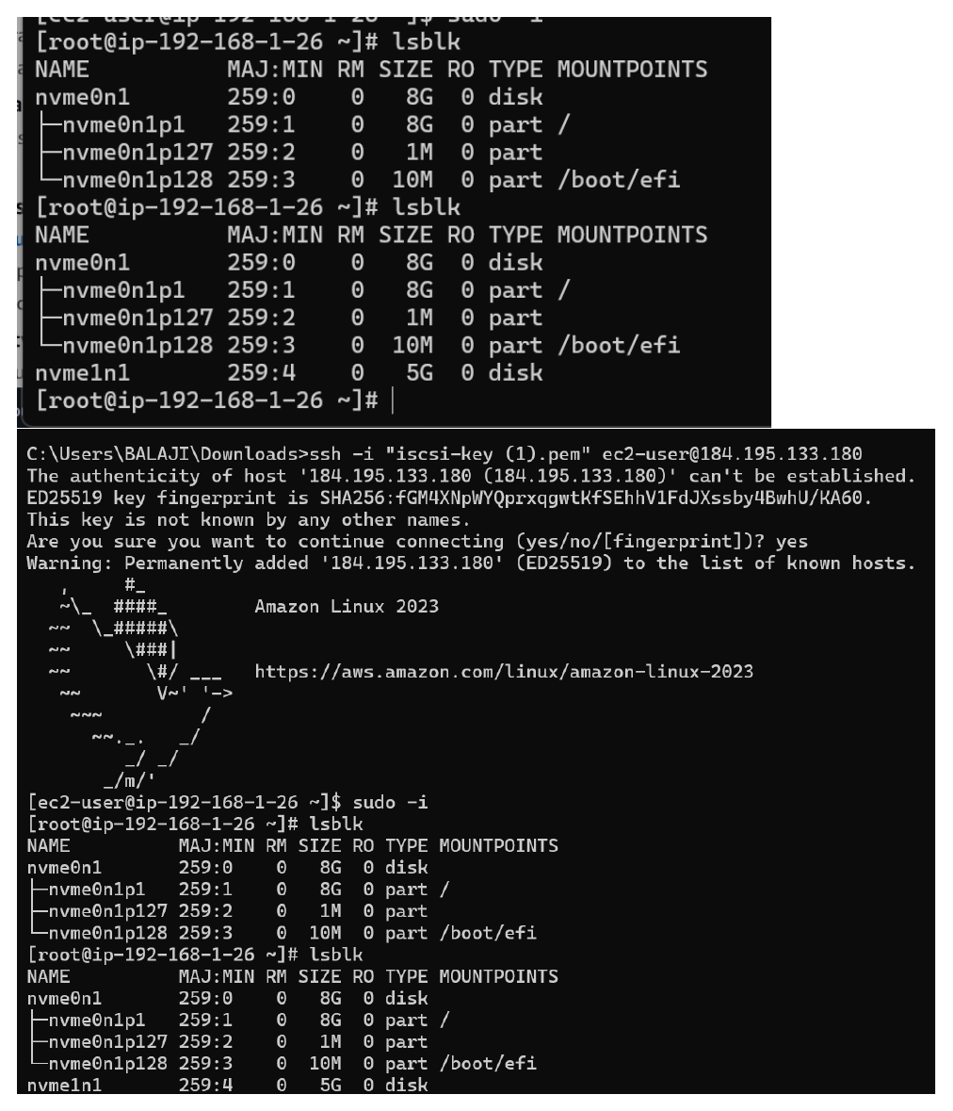
Actual action: lsblk is run before and after attachment to confirm that the additional 5 GiB disk appears as a separate device.

Page 7 — Format the EBS Disk
Topic: XFS filesystem preparation
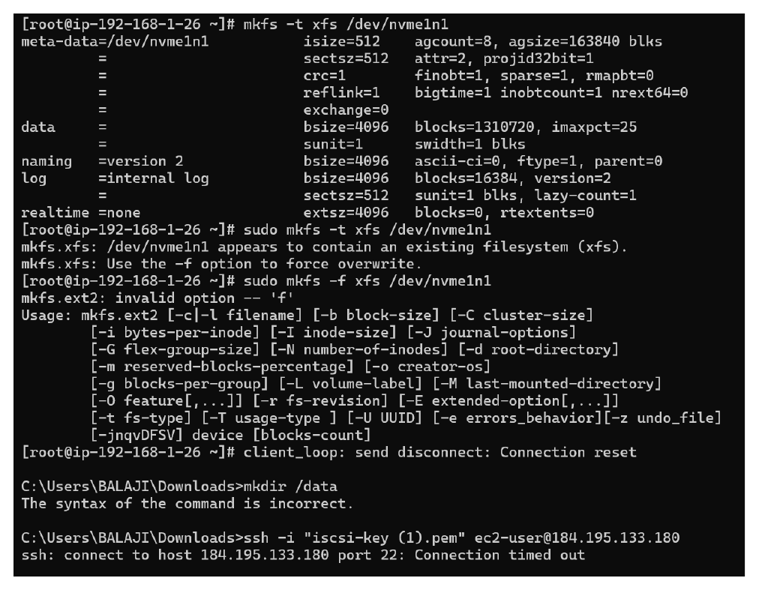
Actual action: mkfs commands are attempted on the new disk; the terminal reports that an existing XFS filesystem is present and shows the connection interruption.

Page 8 — Mount the EBS Volume
Topic: Mount point creation and disk mounting
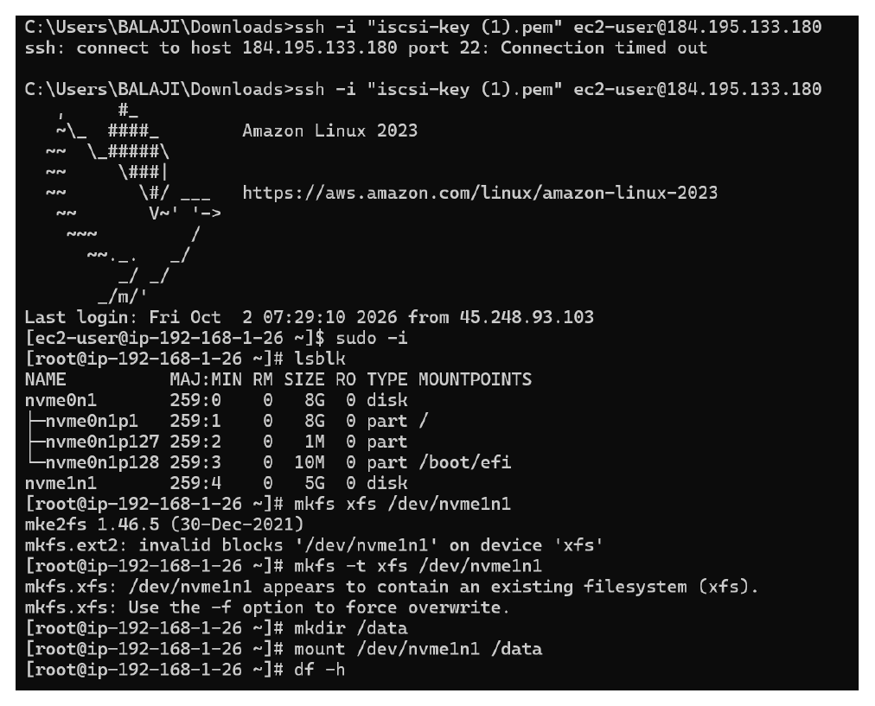
Actual action: The /data directory is created and the EBS device is mounted there, followed by df -h to verify the mount.

Page 9 — Verify the Mounted Storage
Topic: Mount and filesystem verification
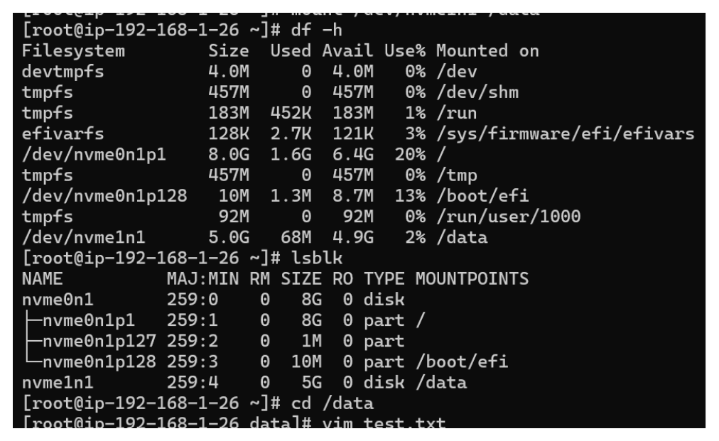
Actual action: df -h and lsblk confirm the 5 GiB volume is mounted at /data, and the shell changes into the /data directory.

Page 10 — Test Data and fstab Preparation
Topic: Test file, UUID, and fstab backup
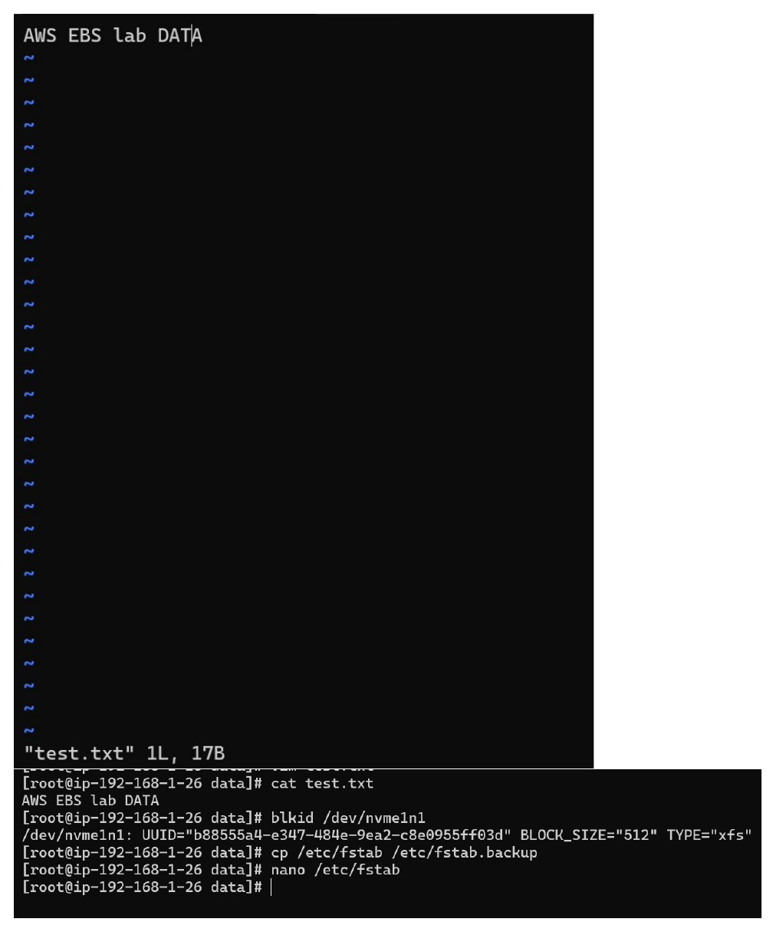
Actual action: The test file is displayed, the volume UUID is obtained with blkid, /etc/fstab is backed up, and fstab is opened for editing.

Page 11 — Unmount Before Persistent Mount
Topic: fstab configuration and unmounting
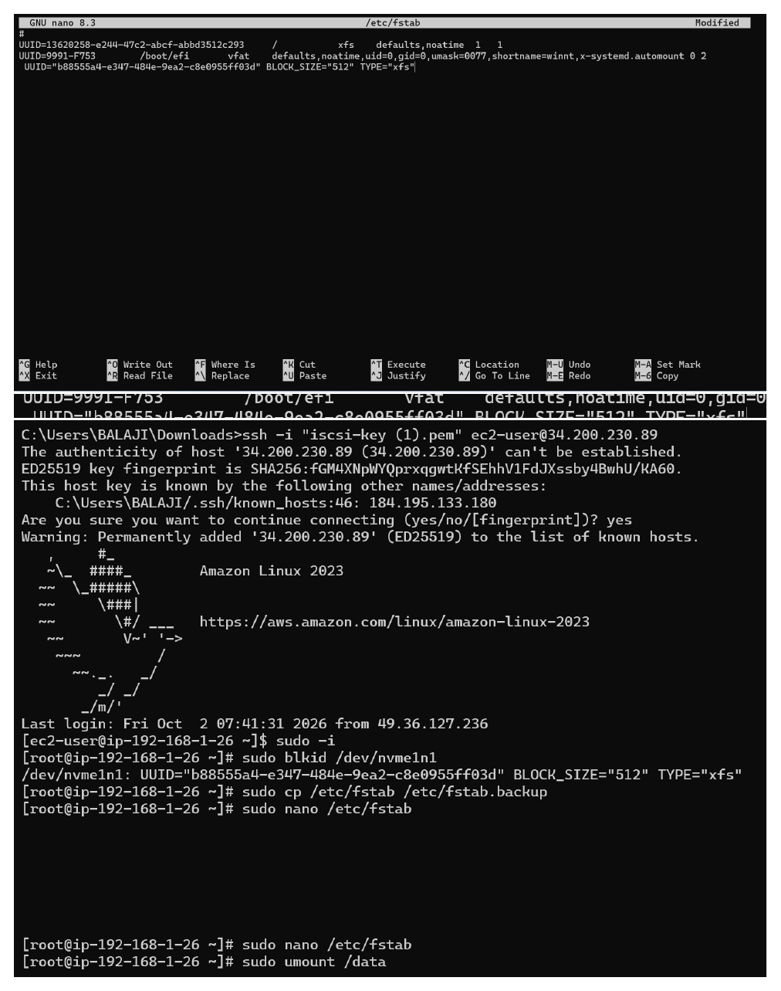
Actual action: The fstab configuration is edited and the /data filesystem is unmounted so the persistent mount configuration can be tested.

Page 12 — Mount Using the Filesystem Configuration
Topic: Filesystem check and remount
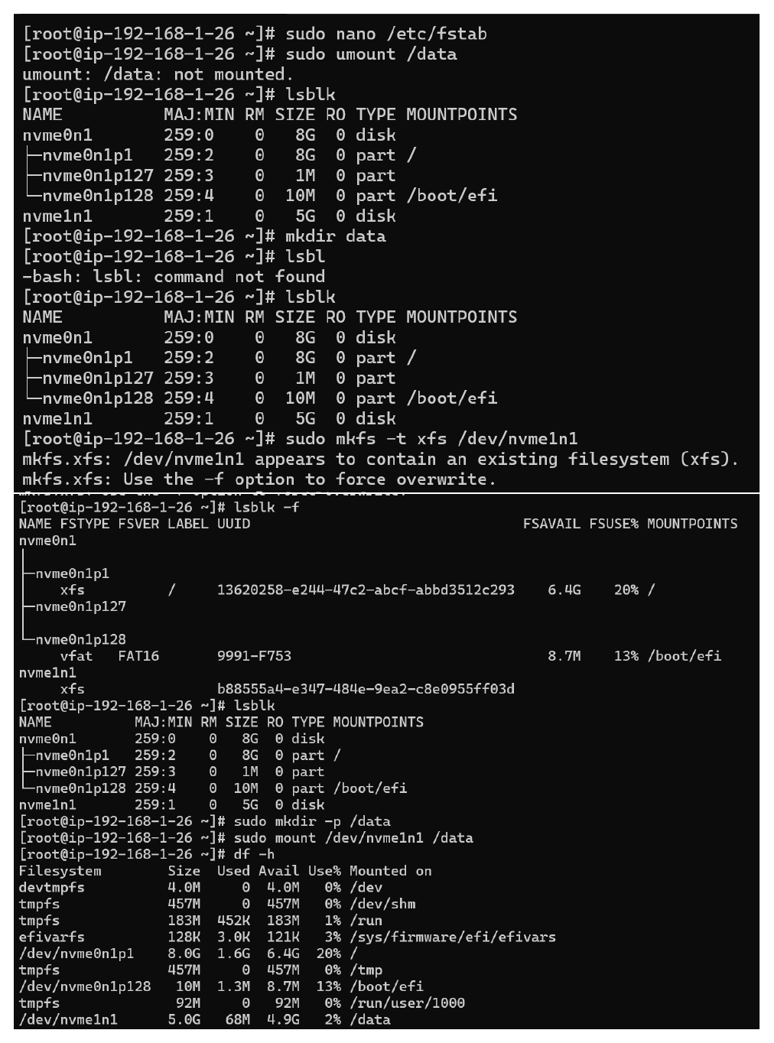
Actual action: The filesystem is checked, /data is recreated, the EBS volume is mounted to /data, and df -h confirms the mounted 5 GiB volume.

Page 13 — Test Persistent Mounting
Topic: mount -a and data persistence verification
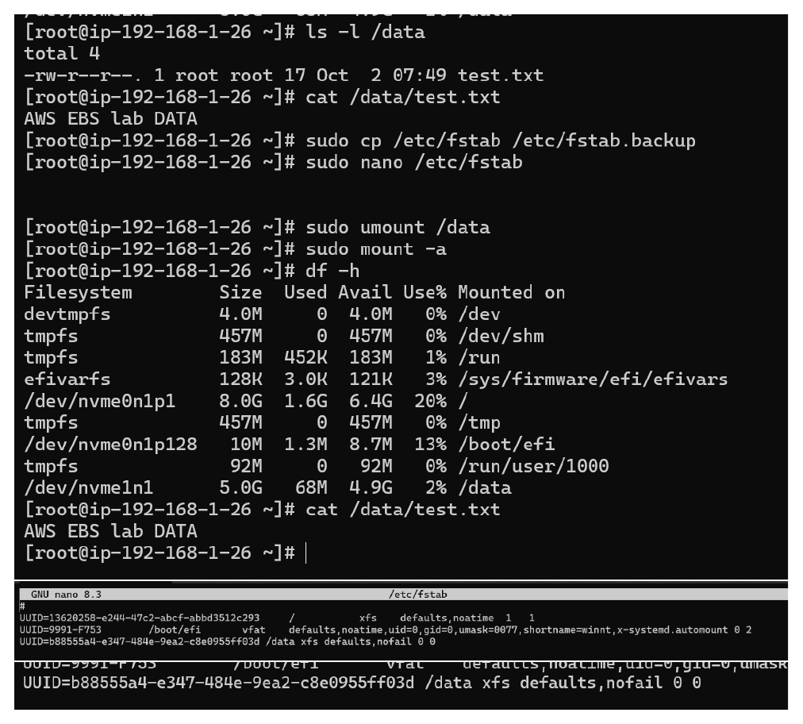
Actual action: The volume is unmounted and mounted again with mount -a; df -h and the test file are used to verify that /data is available and the data remains.

Page 14 — Final EC2 Storage Verification
Topic: Final access and EBS data check
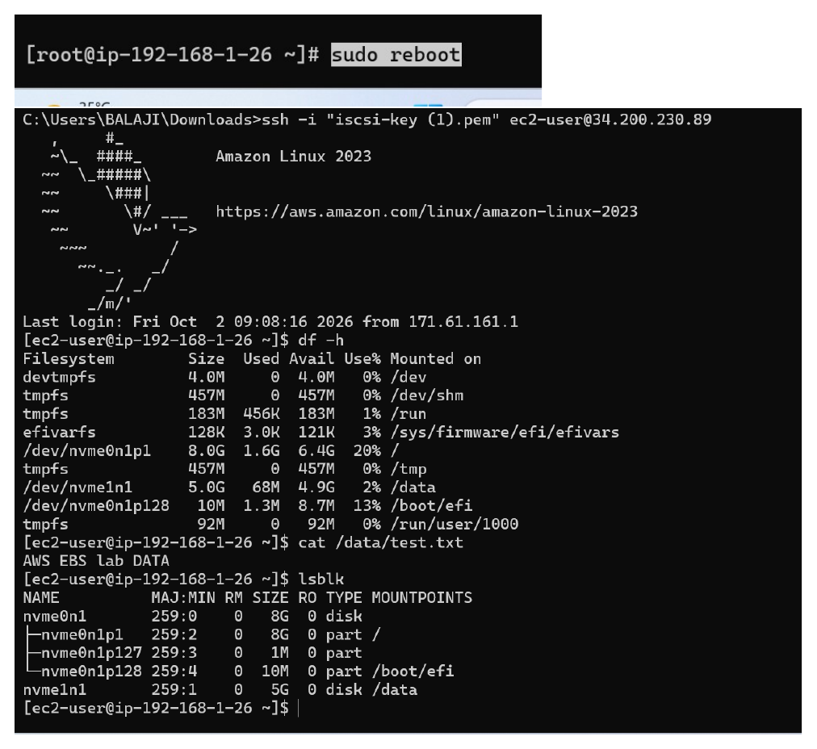
Actual action: The instance is accessed again and df -h, cat /data/test.txt, and lsblk are used to verify the mounted EBS volume and test data.

